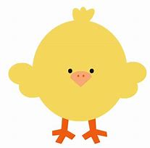

**Understanding the world**

* Talk about the changes that occur in Spring?
* Lots of animals are born in Spring. Can you match the animal and their baby? Horse – foal, sheep – lamb, duck – duckling etc.
* Talk about what happens at Easter and why
* Experiment with ways to safely transport an egg. What materials would you use and why?
* Explore what happens when an egg is placed in a cup of water and salt is added to the cup. Why does this happen?

**Literacy**

* Write a letter to the Easter Bunny
* Write a list of things related to spring, draw a picture to match each item.
* Using Spring words can the children write a song, poem or caption about spring
* Draw or design an egg and label it.

**Maths**

* Decorate an egg with a repeating pattern.
* Egg hunt around the house! How many eggs can you find? Can you match the amount to the correct numeral?
* Ordering found objects by weight or size and using the

correct language to describe them; heavy, light,

long or short.

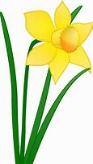

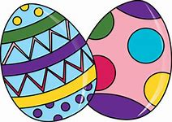

**Physical Development**

* Build or construct an Easter bunny, basket or chick
* Practise letter formation

**PSED and Communication & Language**

* Listen to and read lots of stories. Can the children answer questions about each story?
* Can the children talk about how they are feeling?

**Expressive Arts and Design**

* Create an Easter basket using recycled objects
* Decorate an egg
* Create an animal mask; bunny, lamb or chick etc.
* Use a range of materials to create a spring scene, what colours represent spring?