Monday 14th October

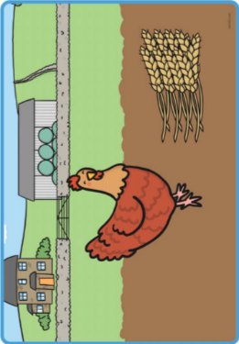TBAT sequence simple sentences

Then she had to take the wheat to the mill. The animals would not help her carry it.

Next the little red hen cut the wheat. The dog, cat and duck did not help her.

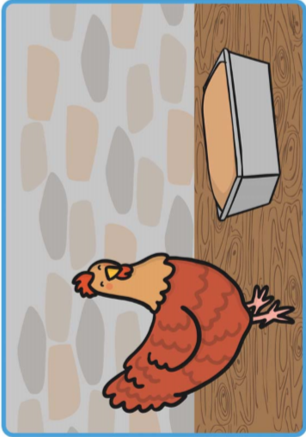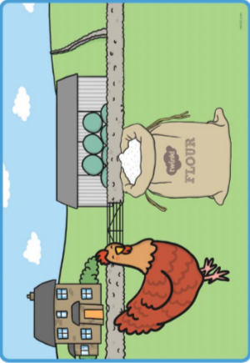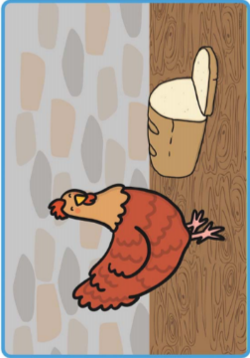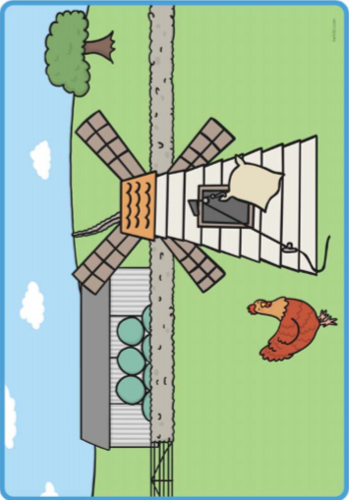

Finally the bread was ready to be eaten. The little red hen ate it all by herself!

The little red hen put the dough in a tin and baked it in the oven. The animals still did not help her!

After that the hen carried the flour back and made the dough. The dog, cat and duck did not help her.